SET 23: EMPLOYEE PERFORMANCE ANALYSIS
Dataset: Employee Performance
Dataset
Employee ID | Department | Years of Service | Performance Score
1 | Sales | 5 | 85
2 | HR | 3 | 92
3 | Marketing | 7 | 78
4 | Sales | 4 | 90
5 | HR | 2 | 76
1. Bar Chart: Employee Distribution by Department
Question: In R, create a bar chart to visualize the distribution of employees across different departments. Label the chart elements.
Aim: To display the number of employees in each department using a bar chart.
Code:
library(ggplot2)
employee_data <- data.frame(
ID = c(1,2,3,4,5),
Department = c("Sales","HR","Marketing","Sales","HR"),
Years = c(5,3,7,4,2),
Score = c(85,92,78,90,76)
)
ggplot(employee_data, aes(x = Department)) +
geom_bar(fill = "steelblue") +
labs(title = "Employee Distribution by Department",
x = "Department", y = "Number of Employees") +
theme_minimal()
Output :
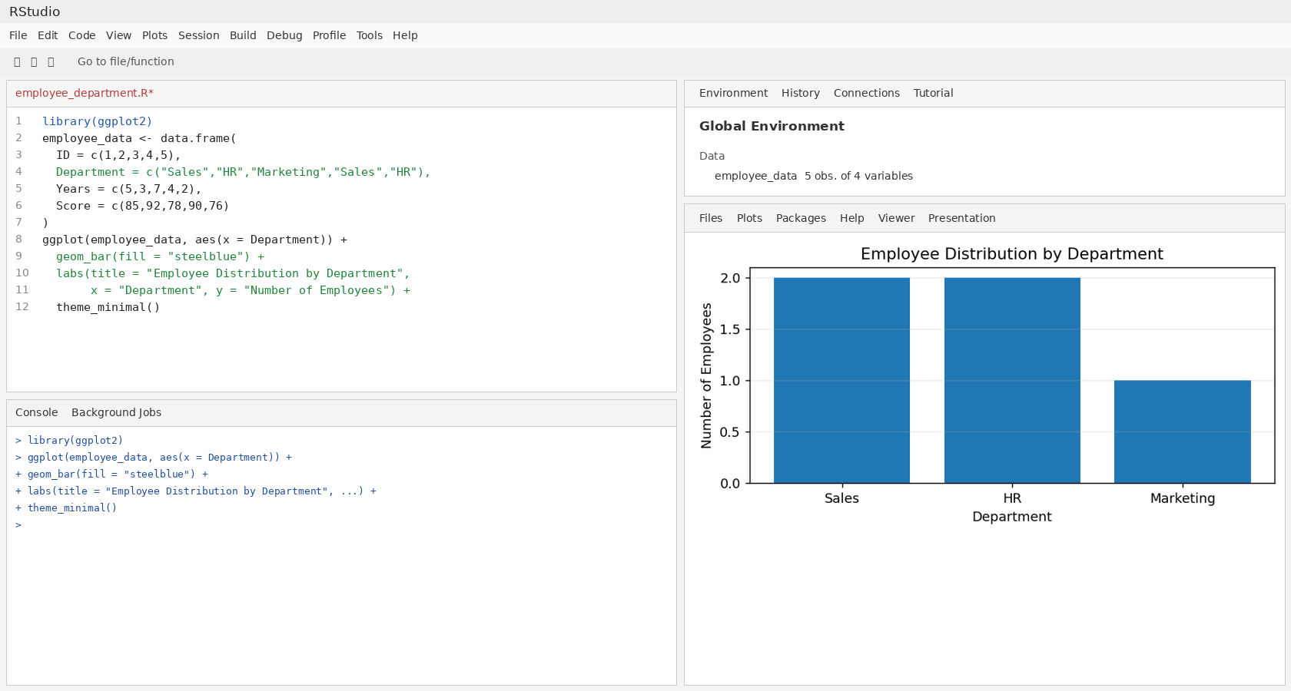
Result: Sales has 2 employees, HR has 2 employees, and Marketing has 1 employee.

2. Line Chart: Employee Performance
Question: In R, generate a line chart to visualize the performance trend of employees over time. Label the axes and title the chart.
Aim: To compare the performance scores of the five employees in the provided dataset.
Code:
library(ggplot2)
employee_data <- data.frame(
Employee = c("E1","E2","E3","E4","E5"),
Score = c(85,92,78,90,76)
)
ggplot(employee_data, aes(x = Employee, y = Score, group = 1)) +
geom_line(colour = "blue", linewidth = 1) +
geom_point(colour = "red", size = 3) +
labs(title = "Employee Performance Scores",
x = "Employee", y = "Performance Score") +
theme_minimal()
Output :
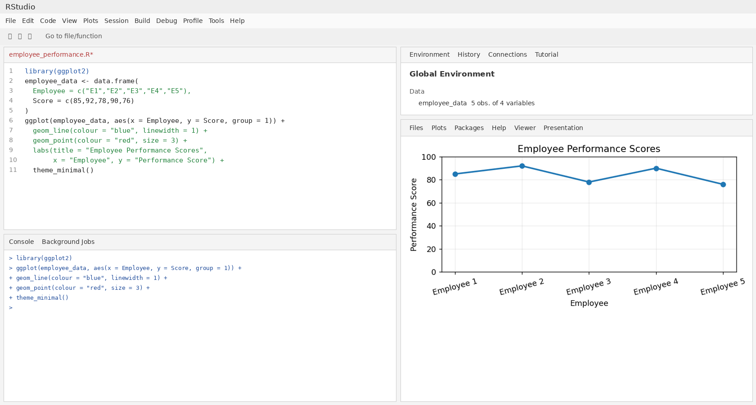
Result: The highest score is 92 (Employee 2), and the lowest is 76 (Employee 5). Employee IDs are used as the sequence because actual time data is not provided.

3. Tableau Dashboard: Department Distribution and Performance
Question: In Tableau, build a dashboard combining a bar chart showing department distribution and a scatter plot displaying the relationship between years of service and performance scores.
Aim: To combine department counts and the relationship between service years and performance scores in one dashboard.
Code:
Tableau steps:
1. Connect to the employee performance dataset.
2. Bar chart: drag Department to Columns and Employee ID to Rows.
3. Change Employee ID aggregation to Count.
4. Scatter plot: drag Years of Service to Columns and Performance Score to Rows.
5. Drag Employee ID to Detail on the Marks card.
6. Create a Dashboard and place both worksheets side by side.
7. Add the title "Employee Performance Dashboard".
Output :
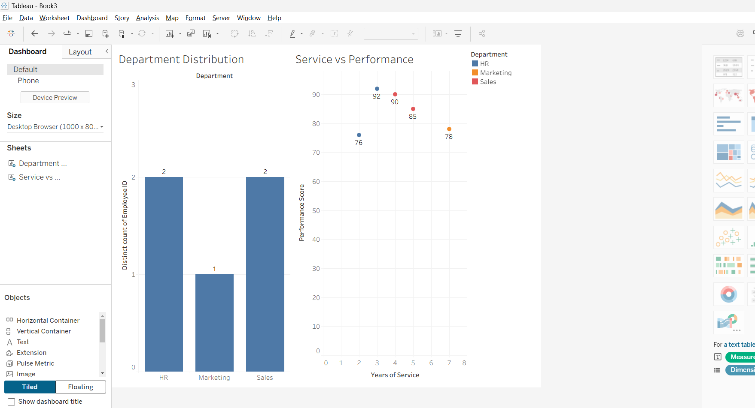
Result: The dashboard shows department distribution and how performance scores vary with years of service. Each employee is represented as a point in the scatter plot.

4. Employee Performance Table in R
Question: In R, develop a table showing the performance data for each employee. Label the table elements.
Aim: To display each employee's ID, department, years of service, and performance score in a clearly labelled table.
Code:
employee_data <- data.frame(
Employee_ID = c(1,2,3,4,5),
Department = c("Sales","HR","Marketing","Sales","HR"),
Years_of_Service = c(5,3,7,4,2),
Performance_Score = c(85,92,78,90,76)
)
print(employee_data)
Output :
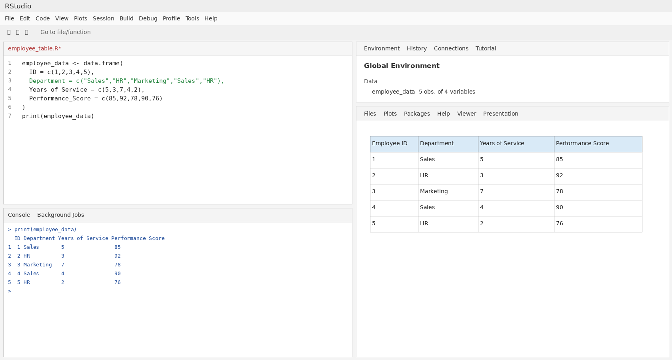
Result: The table displays the details of all five employees, with clearly labelled columns for Employee ID, Department, Years of Service, and Performance Score.

